Nebraska Department of Transportation Mix Design
Jacob Kosmicki
Dr. Lane
Course: CIVE 202
2/31/2026
Client: Federal Highway Administration

Contents
Table of Figures 2
Executive summary 3
Analysis 3
NHTS Data 3
Time-series analysis (NGSIM data) 7
IDM Results 8
Methods 11
Variable selection 11
References 13

Table of Figures
Figure 1 Bar chart of vehicle type 4
Figure 2 Histogram of vehicle age 5
Figure 3 Boxplot of vehicle per household grouped by region 6
Figure 4 Bar chart of vehicles by fuel type 7
Figure 5 Trajectory three graphs 8
Figure 6 Simulated follower position 9
Figure 7 Simulated follower speed 10
Figure 8 Simulated acceleration comparison 11

Executive summary
The following report pertains to the data located in the National Household Travel Survey (hereinafter referred to as NHTS) and the Next Generation Simulation (hereinafter referred to as NGSIM) data located in the CSV given to our firm. Our given tasks were creating clean and simple plots using matplotlib or seaborn libraries in Python that visualize the data over a bar chart, histogram, boxplot, and two time-based plots. Along with this, we have had to create an Intelligent Driver Model (hereinafter referred to as IDM). Due to the variables that are within the plots to be chosen by our discretion, we have also reviewed the data located in the NHTS and NGSIM CSV files. Through this review, we have determined that the variables that provide the most insight into transportation needs are vehicle age, type, fuel type, and per household, grouped by census region, derived from the NHTS data. From the NGSIM, the variables selected were leader_acc(m/s²), follower_speed(m/s) and follower_position(m), leader_speed(m/s) and follower_speed(m/s), and lastly leader_acc(m/s²) and follower_acc(m/s²), each pair or single having its own respective plot and detailed investigations of each graph thereof.

Analysis

NHTS Data
Firstly the bar chart, Figure 1. The chart shows that the largest type of vehicle in the United States is, by far and large an automobile/car/station wagon, outnumbering the second type (SUV) by over 1,500. Pickup trucks come in third with nearly 2,500, with the other types, such as vans, recreational vehicles (RVs), and others containing much smaller counts. This provides insight that passenger vehicles should be prioritized when designing roadway geometries, such as sightlines, super elevation banking, K-values, and turning radii, for new infrastructure. The number of pickup trucks also indicate aa needed focus on pavement strength designs for roadways.

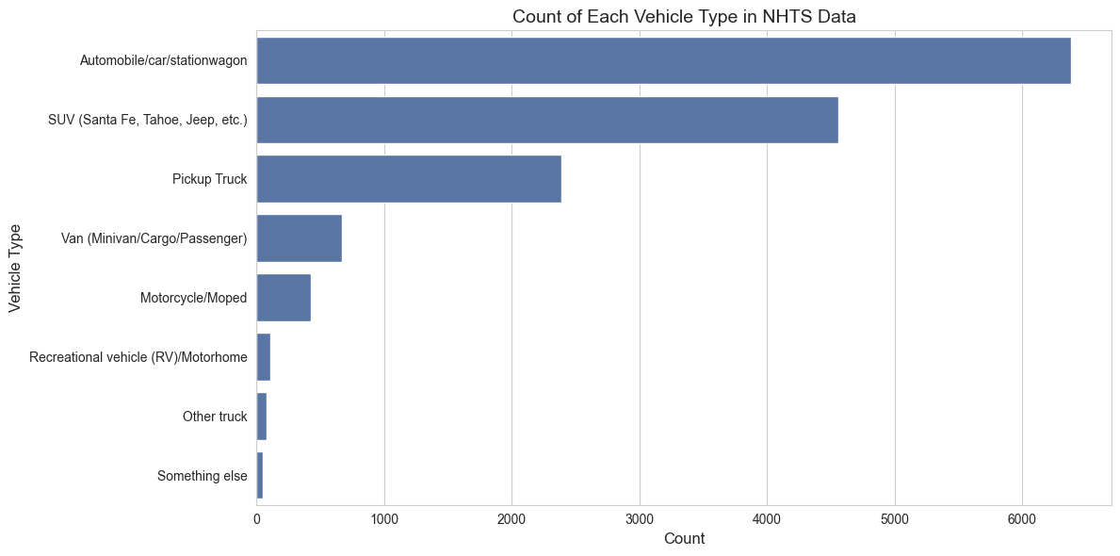
Figure 1 Bar chart of vehicle type
The histogram, Figure 2, is plotted is over the vehicle age distribution in the United States. It reveals newer-skewed data, with the majority of vehicles in the U.S. being 1-2 years old. However, there is a meaningful tail from past ten years old to 25-30 years. This has implications for new emission standards, safety standards and electric vehicle adoption. The long tail suggests that a new push for electric vehicles will be slow to adopt due to the slow turnover rate for the existing gasoline fleet on the road today.
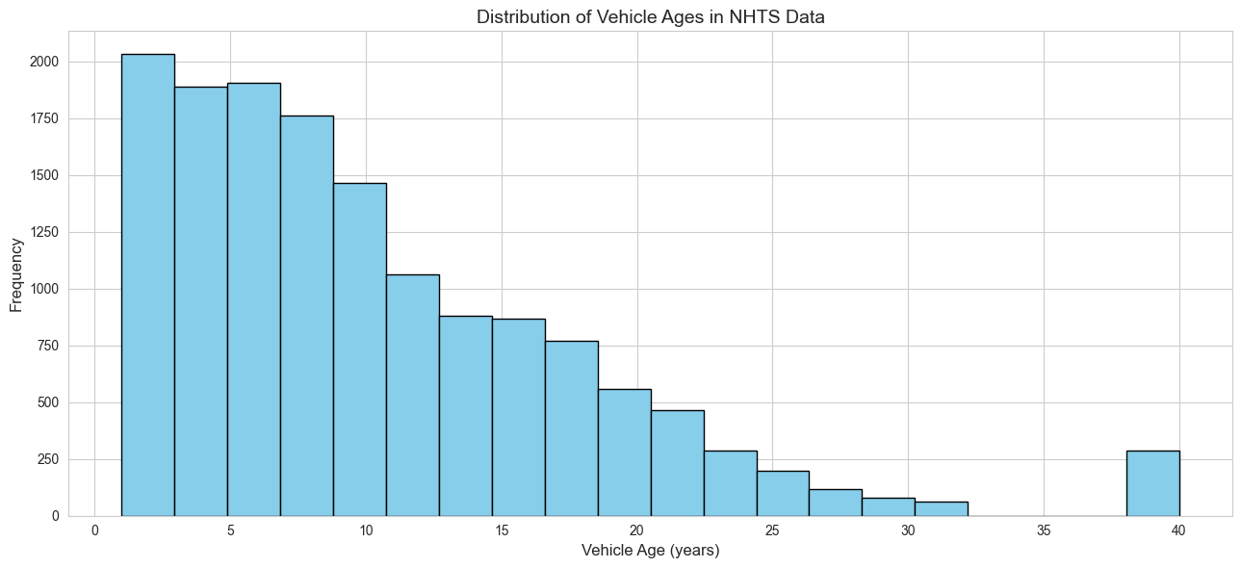
Figure 2 Histogram of vehicle age
The boxplot is shown in Figure 3. This plot illustrates the average number of vehicles ranging from two to three across all of the regions. The South and Midwest regions show higher medians and upper quartiles when compared to the other two regions. This is consistent with a lower population density and lower public transit, which is found in cities such as New York, Boston, and Philadelphia. These differences across the regions can provide insight into whether funds should be allocated towards roadway expansion or transit investment.
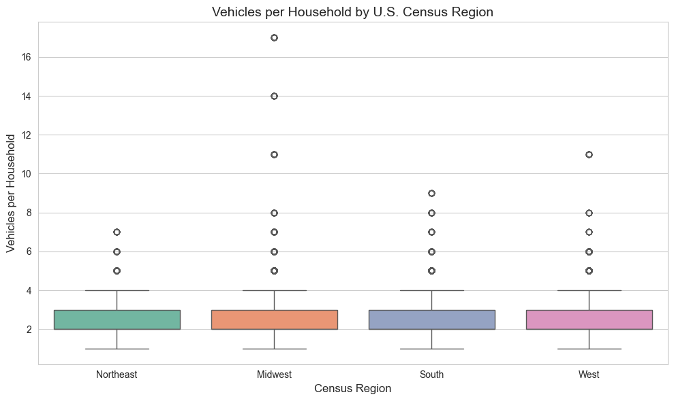
Figure 3 Boxplot of vehicle per household grouped by region
A supplementary bar chart was created in Figure 4. This chart shows that gas-powered vehicles dominate the fleet in the U.S., with over 13,000 of the 14,684 records. The rest of the fuel types share the rest. This is important for emission modeling and infrastructure planning with gasoline production in the future. This also reinforces the conclusions found in the histogram chart of vehicle ages, where it will be a challenge to adopt new electric vehicles.
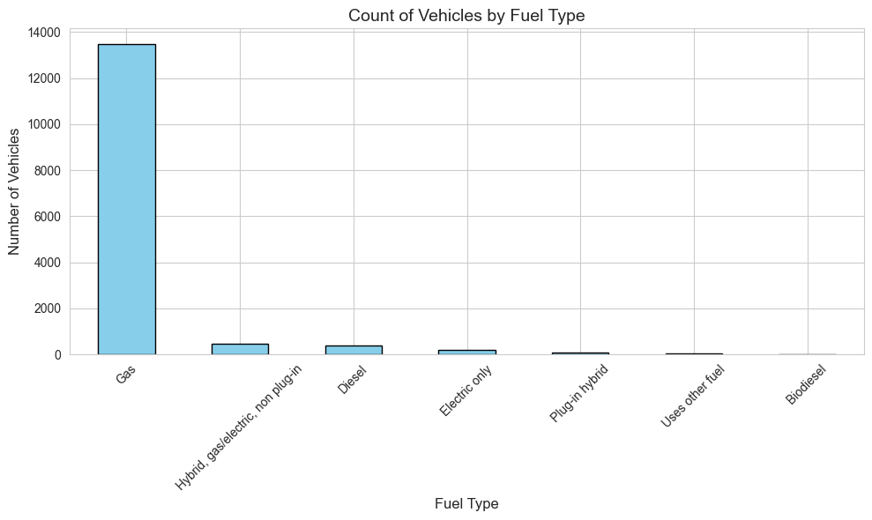
Figure 4 Bar chart of vehicles by fuel type

Time-series analysis (NGSIM data)
Figure 5 is a combined four graphs of the trajectory three pairs. It is speed, position, acceleration, and gap distance all vs time. Speed, position, and acceleration charts have both the leader and follower data in the same graph to see the differences between the two. For the gap distance, it is the difference between the leader and the follower position.
The speed vs time plot shows that the follower tracks the leader's speed profile by a close margin. There is a slight delay that is consistent with the human reaction time of .2 to .25 seconds. The acceleration profile shows more differences within the follower vehicle. It reflects the constant speed changes a driver may make to maintain a comfortable gap to the leader.
The gap distance plot shows that the driver maintains a reasonable distance at the observed speeds, consistent with safe following distances. Periods of decreasing gap correlate with the follower traveling faster than the leader, while increasing gaps correlate with the opposite. If the gap distance continues, it can lead to potential rear-end collisions.
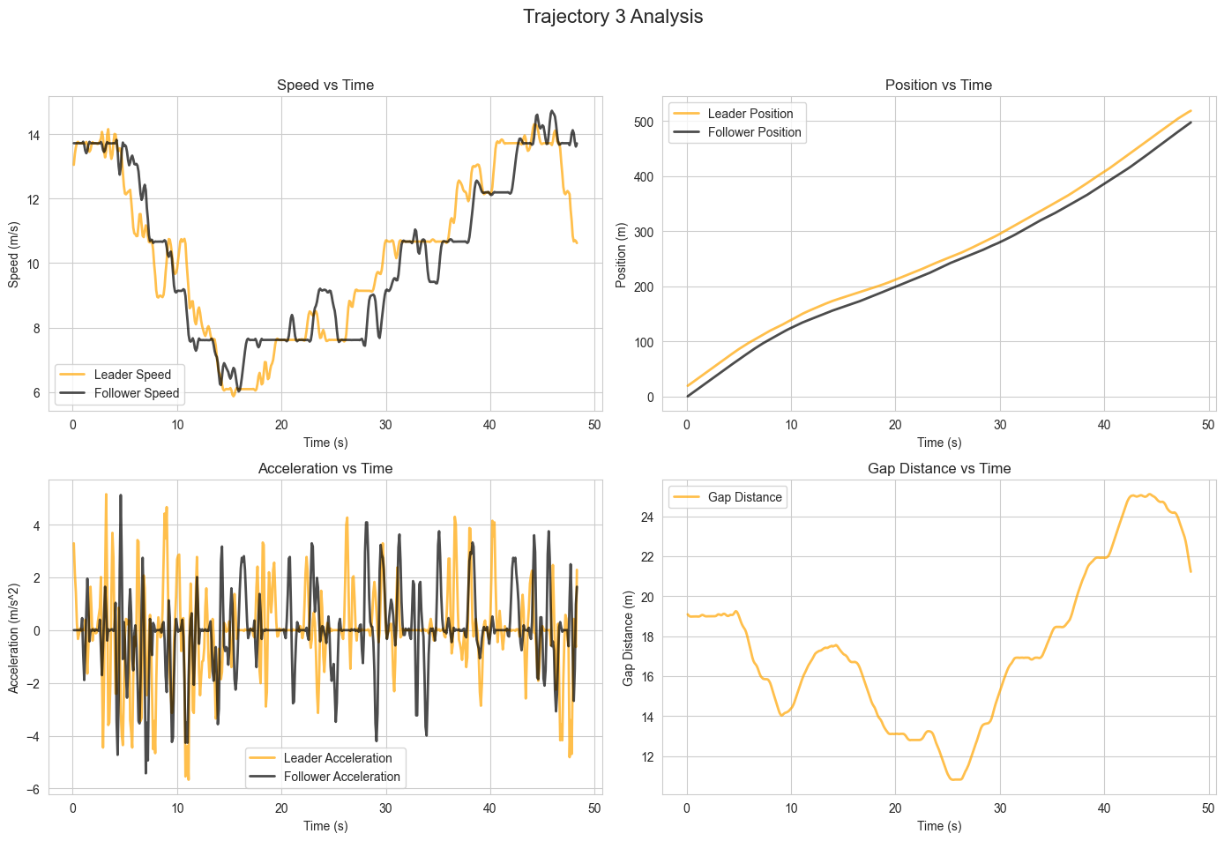
Figure 5 Trajectory three graphs

IDM Results
The IDM simulation was run using trajectory pair number three from the NGSIM data. The analysis was over position, speed, acceleration, and gap distance.
The position chart is in Figure 6. The simulated follower generally follows the real follower data, but it consistently sits above it for most of the simulation. The largest gap appear to be somewhere around the middle of the observation
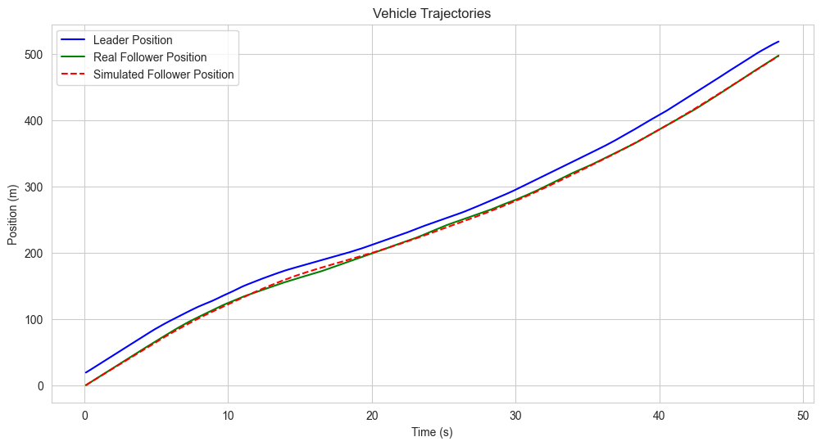
Figure 6 Simulated follower position
The speed comparison plot is Figure 7. The real follower speed is notably prone to sharp increases and decreases. This reflects how real driver consistently adjusts with the use fot he throttle and brake in their car. The simulated speed follows a much smoother curve. The simulation captures the overall speed trends of the data but misses the short impulsive speed changes that occur in the real data.
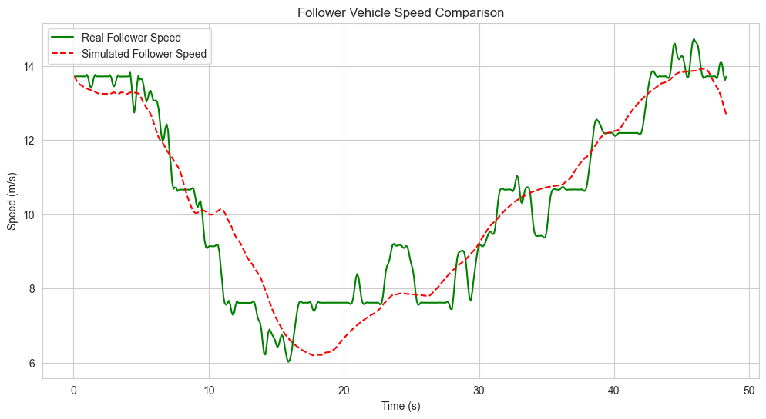
Figure 7 Simulated follower speed
The acceleration simulation comparison plot is Figure 8. This is where the simulation has the most dramatic differences from reality. Both the leader and follower acceleration lines show large, sharp spikes in both peaks and valleys across the observation, the follower with having more so. The simulation is nearly flat by comparison, having gently sloping changes. The IDM smooths out all the aggressive driving behavior of real life by computing one acceleration each step, not overshooting, hesitating, and reacting to real-time events like real drivers do.
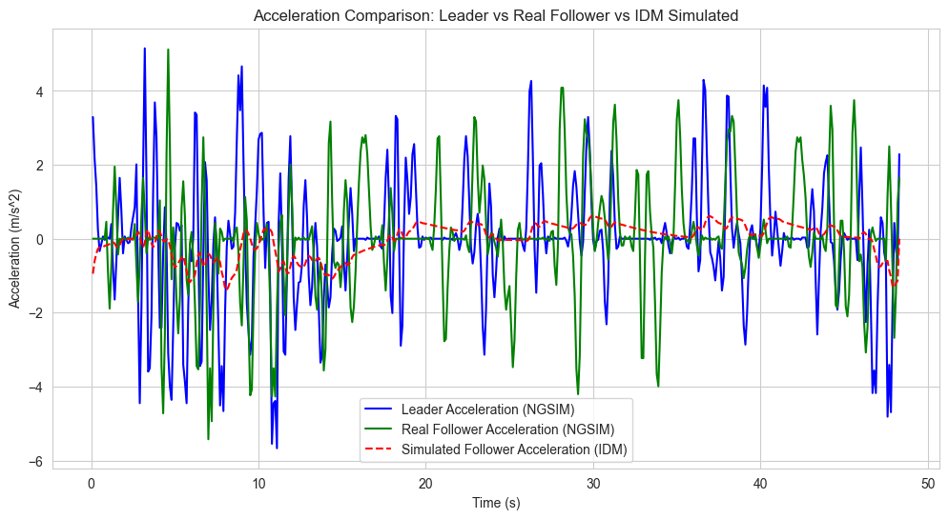
Figure 8 Simulated acceleration comparison

Methods
Two data sets were provided to our firm by the FHWA and were utilized in this analysis. The NHTS contains over 14,000 records in over 23 columns. The data describes household-level characteristics of travel, including vehicle ownership, household demographics, vehicle type, fuel type, and geographic information. The NGSIM data was collected at 0.1-second intervals across 16 trajectory pairs. Both data sets were loaded into a Python code document using pandas library and reviewed.

Variable selection
NHTS Variables
Three NHTS variables were chosen by their relevance to the project and transportation engineering per the instructions The variables selected from the data were vehicle type, vehicle age, and vehicles per household grouped by census region.
The vehicle type was selected due to the insight it provides into what roadway infrastructure needs to be designed for. Such as K-values, super elevations, sightlines, and radii turns. It also affects emission projections and loading pavement designs.
Vehicle age was chosen because the age distribution among vehicles affects safety policy on roadways, emission standards, and fleet turnover.
Vehicles per household was grouped by census region. This was selected because regional differences influence traffic and transit demands in different parts of the country. Regions with higher ownership may need less public transit but more roadway capacity.
An additional variable was calculated in fuel type to show fleet energy usage and needs for the future.
NGSIM Variables
The NGSIM dataset was used to visualize and compare time series-based driving behavior. The variables selected were follower speed (m/s), follower acceleration (m/s²), leader and follower position (m), and the computed gap distance between the leader and follower vehicles. These variables were chosen based on how they capture the flow of traffic, such as the safety following distance, and traffic flow theory. Capture theory pair three was selected for the analysis as well as the IDM simulation.
Plot Construction
All plots were constructed in a
All plots were constructed in Python using a Jupyter notebook environment. Matplotlib and seaborn libraires were used to create the plots. The seaborn whitegrid style and deep color palette were applied globally at the start of the notebook to ensure consistency across the plots. Each plot was given a title and labeled axes with units per the instructions.
The bar charts were made using seaborns countplot or barplot function. The NHTS dataset was grouped by vehicle type then the count of each record was computed using pandas value_count function. The bar chart was then populated using vehicle type on the x-axis and frequency on the y-axis.
A historgram plot was created using the vehicle age, this used matplotlib’s hist function or seaborn’s histplot. The bin width was set to one year. Th x-axis represents the vehicle age in years and the y-axis represents the number of vehicles.
A box plot was constructed using seaborn’s boxplot() function with census_region on the x-axis and vehicles_per_household on the y-axis. This plot displays the median, middle range and outliers for vehicle ownership in the four regions of the U.S. Census region.
The follower and leader speeds were plotted against time using seaborn’s lineplot function. Both lines were overlaid on the same plot with different colors to differentiate the two. A legend was also added for easy readability.
The gap distance between the leader and follower position at each step (gap=leader position-follower position). This variable was plotted against time using matplotlip’s plot function with a specific line width of two.
A 2x2 subplot figure was created using matplotlib’s subplots function to display position, speed, acceleration, gap distance for trajectory pair 3 specify all simultaneously. Each plot was created using consistent color and other shared formatting. The subplot positions were rearranged from the default configuration.
Reference the annotated code document for the Python code required for each step.
Intelligent Driver Model (IDM) Simulation
An IDM simulation was preformed in Python to model car-following behavior.
An IDM simulation was implemented in Python to model and visualize car-following behavior. The IDM is a deterministic microscopic traffic flow model developed by Treiber, Hennecke, and Helbing (2000) that computes a vehicle's acceleration as a function of its current speed, the speed difference relative to the lead vehicle, and the gap between vehicles. The IDM acceleration equation is:
a = a_max · [1 – (v / v₀)ᵟ – (s*(v, Δv) / s)²]
where a_max is the maximum acceleration, v is the current speed, v₀ is the desired speed, δ is the acceleration exponent, s is the current gap, and s* is the desired minimum gap:
s*(v, Δv) = s₀ + v · T + (v · Δv) / (2 · √(a_max · b))
where s₀ is the minimum spacing at rest (2 m), T is the desired time headway (1.5 s), and b is the comfortable deceleration (1.5 m/s²). The desired velocity was set to 30 m/s and the acceleration exponent to 4.
The simulation was run using a forward-Euler time-stepping scheme at 0.1-second intervals. The leader vehicle's trajectory was taken directly from the NGSIM data for trajectory pair 3, and the follower vehicle's motion was simulated using the IDM equations. The simulated follower trajectory was then compared to the observed NGSIM follower trajectory to assess how well the model performs.

References
Anthropic. (2026). Claude (Claude Opus 4.6) [Large language model]. https://claude.ai
Claude was used to help solve problems with the code and gather references. It was also used to help come up with ideas for graphs from the code.
Federal Highway Administration. (2023). Next Generation Simulation (NGSIM). U.S. Department of Transportation. https://ops.fhwa.dot.gov/trafficanalysistools/ngsim.htm
Federal Highway Administration. (2022). National Household Travel Survey (NHTS). U.S. Department of Transportation. https://nhts.ornl.gov/
Treiber, M., Hennecke, A., & Helbing, D. (2000). Congested traffic states in empirical observations and microscopic simulations. Physical Review E, 62(2), 1805–1824. https://doi.org/10.1103/PhysRevE.62.1805

